Lab 2: Synthetic Data and Evaluating Patterns in R

By: Yvette Lindler, Leon Davis, Jennifer McLean, and Jim Graham

10th of February, 2020

Methods

Linear regression will be evaluated in the statistics package R by creating synthetic linear trends and injecting noise into the resulting data. Linear models will be fitted to the data and then the residuals will be evaluated using histograms. Four different sets of data, or runs, will be created with different parameters for the equations that create the trends and noise (Table 1).

Table 1. Equations and parameters for the noise (error, ϵ) that will be injected into the data. The Mean and Standard deviation define the parameters for the normal distribution used to generate the noise.
Model | Equation | Mean (µ) | Standard Deviation (σ)
1 | $$y=x+ ϵ$$ | 0 | 10
2 | $$y=10+2x+ ϵ$$ | 0 | -1
3 | $$y=5x+ ϵ$$ | 10 | 1
4 | $$y=2-3x_{1}+{2x}_{2}+ ϵ$$ | 0 | 0

Results

Results show the range of the random data increases with increasing standard deviation (Figure 1) and the relationship between the Y Values and X Values for each model (Figure 2).
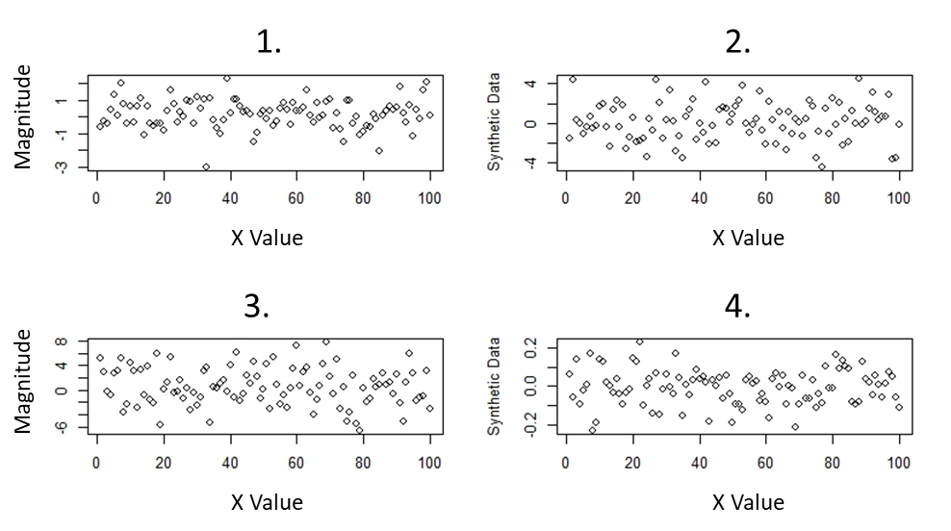
Figure 1. Plots of the magnitude of the noise that was added to the data for each X Value.
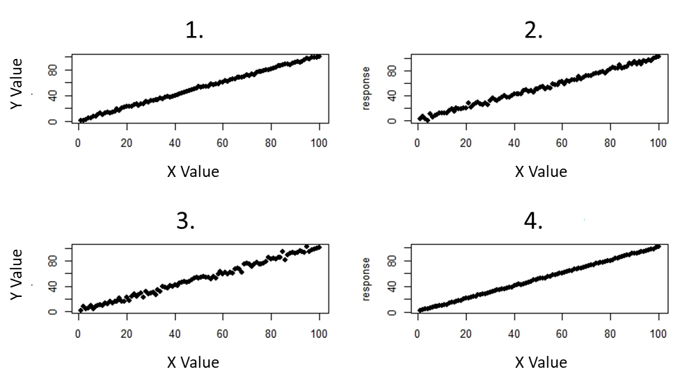
Figure 2. Trends with added noise for each run where the y value is the response and the x value is the independent variable.

Performance measures showed that the ability for R to fit a linear trend to the data was correlated with the amount of noise that was injected into the data (Table 2).

Table 2. Performance results for each model run.
Model | R²
1 | 99.87%
2 | 99.47%
3 | 99.09%
4 | 99.97%

Histograms of the residuals (Figure 3) from linear models, incorporating the altered standard deviations, reveal increased residual distance for models with higher standard deviations, and decreased residual distance for models with lower standard deviations.
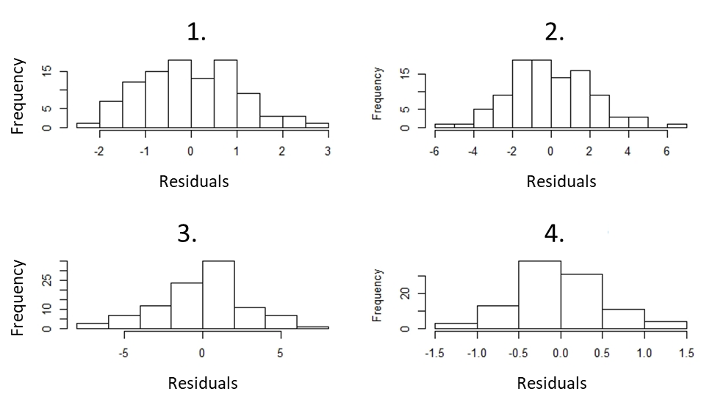
Figure 3. Histograms of the residuals for each model with varying degrees of standard deviation.

Changing standard deviations also changed the structure of each model (figure 4). No noticeable pattern was found in the models as standard deviations changed. Changing the standard deviation resulted in models with poor fit to the data. Each model determined the intercept and explanatory variable to be significant predictors of the response (p<.05).

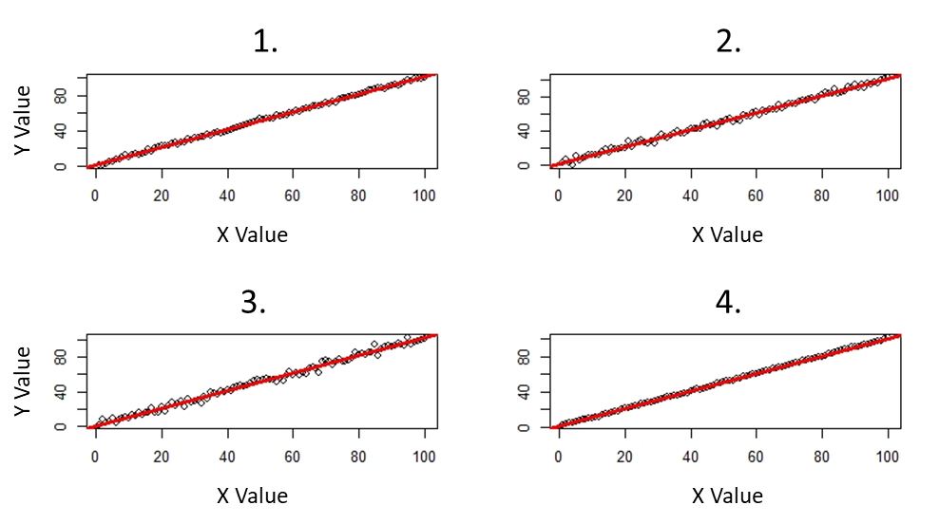
Figure 4. Models fit to their respective datasets for each run.

Creating Two Dimensional Data
The model with two independent variables showed the same behaviors as the ones with one independent variable except 3D plots were used to visualize the results (Figure 5, Figure 6).

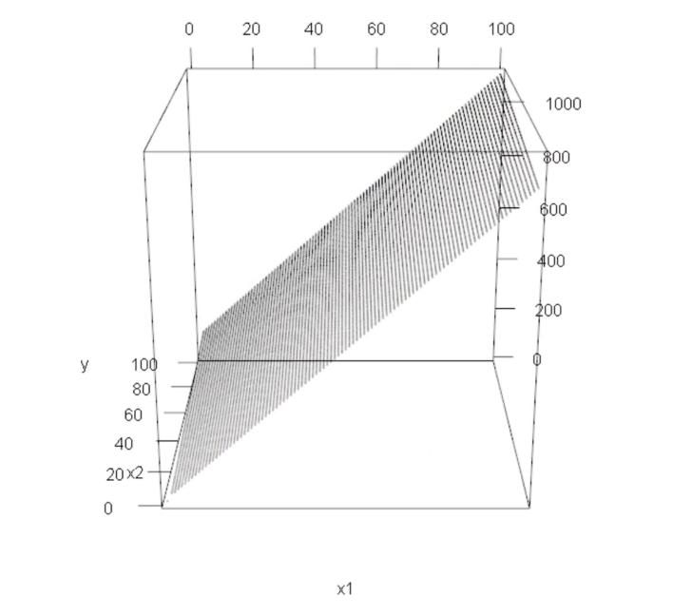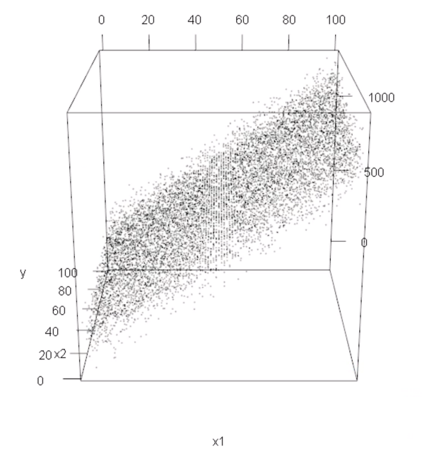
Figure 5: A three dimensional plot of a linear trend between two independent variables.

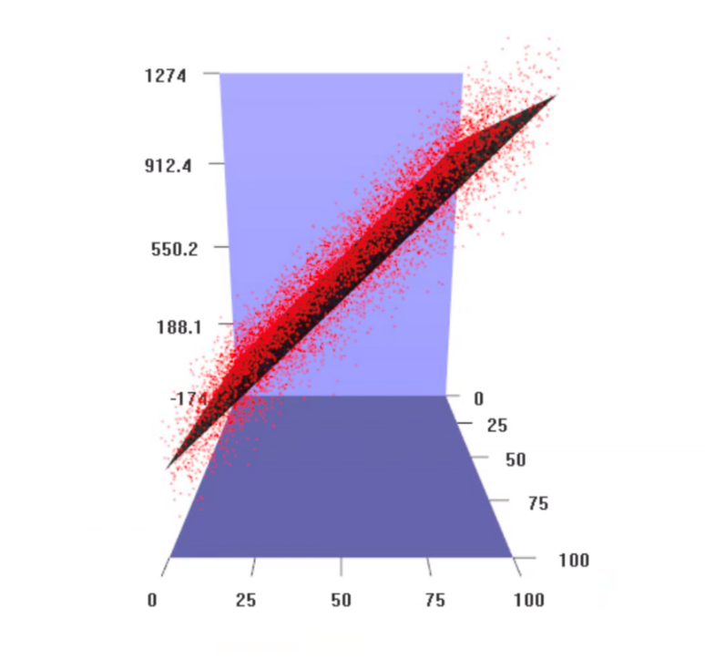
Figure 6: A three dimensional plot based on a two-dimensional matrix created by model parameters or coefficients.

Questions

QUESTION 1. What effect does the mean and stdev have on the data?

The mean and stdev are sensitive to outliers, as they can skew the data and create distortion within a picture. The mean can increase when a data point >mean is added or <mean is taken away and vice versa. The stdev measures the spread of the data distribution, the greater the spread = the greater stdev and vice versa. However, stdev cannot be negative. stdev close to 0 indicates the data points are close to the mean

QUESTION 2. What effect does setting B1 to 10 have? What effect does setting B1 to -1 have?

B1 is the slope parameter and it tells the relationship between two variables. A slope of 10 would mean a small change in variable x would have a greater changer in variable y, which means it is more linear. A slope closer to 0 would result in a horizontal line which means there is little to no relationship between variables x and y.

QUESTION 3. What effect does changing B0 have?

B0 is equal to the y-intercept. If B0 is set to a number, the plot would increment by 1 and start at the following number. i.e. if B0=5, the printed values and plot for the y-intercept would start at the value of 6. If B0 was set to 10, the y-int would start at 11 and increment up or down (depending on slope) from there.

QUESTION 4. What effect does increasing and decreasing the value of the standard deviation in the random function have?

Having a lower RandomStDev value would decrease the noise produced. If the stdev was set to 1, the plot for RandomValues would be linear with a positive trend. If the stdev was set to 100, the data points would be scattered with a lot of noise and the linear trendline would be horizontal, meaning there is little relationship between independent and dependent variables.

QUESTION 5. How well does R find the original coefficients of your polynomials?

R’s ability to find the original coefficients depends on the amount of noise produced by the given standard deviation. With a low set stdev, R will find precise coefficients of the model compared to a higher stdev.

QUESTION 6. How good a job did the prediction do at removing the trend in your data?

The trend of the data shows the predicted model, which identifies an error in the code.

QUESTION 7. What effect does increasing and decreasing the values of B3 and B4?
Changing the values of B3 and B4 will change the slope direction.
QUESTION 8. What is the value of Moran's I?
0.951001

Acknowledgements

Thank you to Professor Jim Graham for guiding us through our first lab activity using R.

References

RStudio Team (2019). RStudio: Integrated Development for R. RStudio, Inc., Boston, MA
URL http://www.rstudio.com/

Appendix A – R Code

############## Changing the standard deviation
##### response
n=seq(1:100)
noise=rnorm(n,mean = 0, sd=1)
#### explanatory
x=seq(1:100)
x1=rnorm(x, mean=0, sd=2)
x2=rnorm(x, mean=0, sd=3)
x3=rnorm(x, mean=0, sd=.5)
par(mfrow=c(2,2))
plot(x, main = 'mean=0, sd=1', ylab='Synthetic Data')
plot(x1,main = 'mean=0, sd=2', ylab='Synthetic Data')
plot(x2,main = 'mean=0, sd=3', ylab='Synthetic Data')
plot(x3,main = 'mean=0, sd=.5', ylab='Synthetic Data')

####### generate some noise

n1=rnorm(x, mean=0, sd=2)
n2=rnorm(x, mean=0, sd=3)
n3=rnorm(x, mean=0, sd=.5)
####### data fit to response
b0=1
b1=1
y=b0+(b1*x)+noise
y1=b0+(b1*x)+ n1
y2=b0+(b1*x)+ n2
y3=b0+(b1*x)+ n3
plot(x,y, xlab='explanatory', ylab = 'response', main='mean=0, sd=1', pch=16)
plot(x,y1, xlab='explanatory', ylab = 'response', main='mean=0, sd=2',pch=16)
plot(x,y2, xlab='explanatory', ylab = 'response', main='mean=0, sd=3',pch=16)
plot(x,y3, xlab='explanatory', ylab = 'response', main='mean=0, sd=.5',pch=16)

######## Histograms
m1=lm(y~x)
m2=lm(y1~x)
m3=lm(y2~x)
m4=lm(y3~x)
par(mfrow=c(1,1))
hist(resid(m1),main='mean=0, sd=1',xlab = 'Residuals')
hist(resid(m2),main='mean=0, sd=2',xlab = 'Residuals')
hist(resid(m3),main='mean=0, sd=3',xlab = 'Residuals')
hist(resid(m4),main='mean=0, sd=.5',xlab = 'Residuals')

##### model strucutre
print(m1)
print(m2)
print(m3)
print(m4)
summary(m1)
summary(m2)
summary(m3)
summary(m4)

plot(y~x, xlab='explanatory', ylab = 'response', main='Y=1.10+1*x;R-squared=99.87%')
abline(m1, col='red',lwd=3)
plot(y1~x, xlab='explanatory', ylab = 'response', main='Y=.96+1*x;R-squared=99.47%')
abline(m2, col='red',lwd=3)
plot(y2~x, xlab='explanatory', ylab = 'response', main='Y=.81+1*x;R-squared=99.09%')
abline(m3, col='red',lwd=3)
plot(y3~x, xlab='explanatory', ylab = 'response', main='Y=.95+1*x;R-squared=99.97%')
abline(m4, col='red',lwd=3)

######## autocorrelation
RandomMean=0
RandomStdDev=1

RandomValues=rnorm(NumEntries, mean = RandomMean, sd = RandomStdDev);

Frequency=0.3
Magnitude=45

Y=B0+B1*X + RandomValues + sin(X*Frequency)*Magnitude

lm1=lm(Y~X+RandomValues)
summary(lm1)
lm2=update(lm1,.~.-RandomValues)
summary(lm2)
lm.p=predict.lm(lm2)
lm.p=order(lm.p)
par(mfrow=c(1,1))

plot(Y,pch=16, main = 'Y=8.23+.88*x; R-squared=38.79') ########## linear model

abline(lm2,col='orange')

TheMean=mean(Y) # find the overall mean of the array

# find the sum of squares

SumOfSquares=0
for (i in 1:NumEntries ) {
SumOfSquares=SumOfSquares+(Y[i]-TheMean)^2
}
print(SumOfSquares)

# find the sum of the weighted differences
TheWeights=0
TheSum=0
for (i in 1:NumEntries ) {
for (j in 1:NumEntries )
{
if (i!=j) # don't compute differences between the same values
{
TheWeight=1/((i-j)^2) # compute a weight based on position in the array (i-j)
TheWeights=TheWeights+TheWeight # add the weights to an overall sum of weights

# the key equation where were add the weighted differences from the mean and sum it
TheSum=TheSum+TheWeight*(Y[i]-TheMean)*(Y[j]-TheMean)
}
}
}
# scale the sum to be from 0 to 1
MoransI=(NumEntries/TheWeights)*(TheSum/SumOfSquares)
print(MoransI)

####### Beta Changing
B0=1
B1=2
B2=5
B3=-20
Y=B0+B1*x+B2*x^2+B3*x^3 + noise

plot(Y)

